Angular 4/5 project:

Task Management tool for company Bruce Fox.

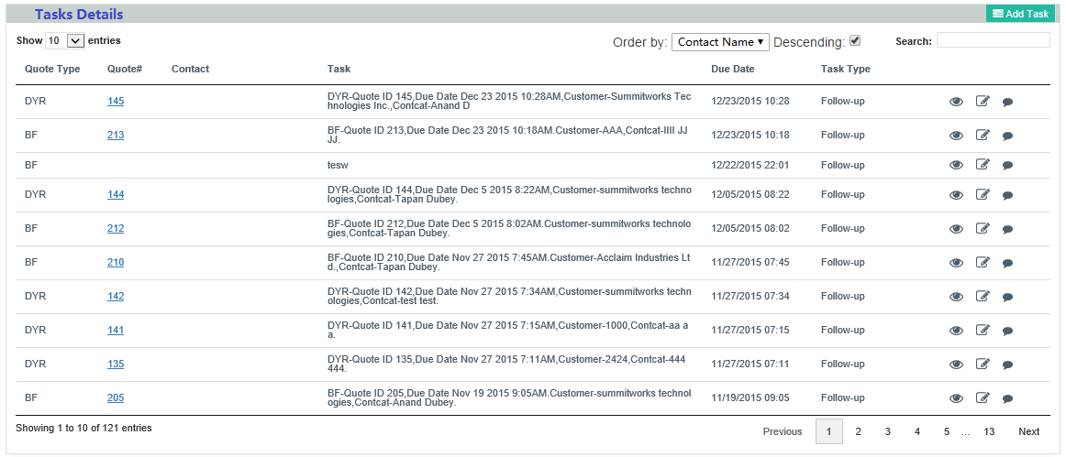

Requirement:

1. Create a html web page including function of showing a list of tasks, editing an existing task[Use separate component as child & use @input & @output for passing data]. (finished)
2. Add New Task in new page => implement Routing for it (finished)
3. Use Route Guards for Authentication (Finished)
4. Use Web API and entity framework to fetch the data. (Finished)
5. Search: Use search parameter to an HTTPclient Request [Angular 4 feature] (finished with angular pipe)
6. Order By. (Finished)
7. Use pipe(filter) titlecase (Finished)
8. Paginate (**ngx-pagination) or Angular Material (finished by ngx-pagination)**
9. For adding a new task and updating a task, use Bootstrap modal Dialog. Or Angular Material (Finished Add new task)
10. Add validation for adding and updating task. (Finished)
    1. All fields are required.
    2. Quote#: number,
    3. Due Date: date.
    4. Status should be a drop down with Close and Open options. (no)
11. Use Lambda providers feature from Angular 5.
12. Blur & submit events feature from Angular 5.

